

movie ticketing system

SSDI Project – Group 1



Team:

DAKSHINYA BHARATHI GUDIPATI

YATIN KIRI

VINOD PALREDDY

PRATHYUSHA MOPARTHI

MAHESH KURVA

# Detailed Design:

1. **UML Class Diagram :**

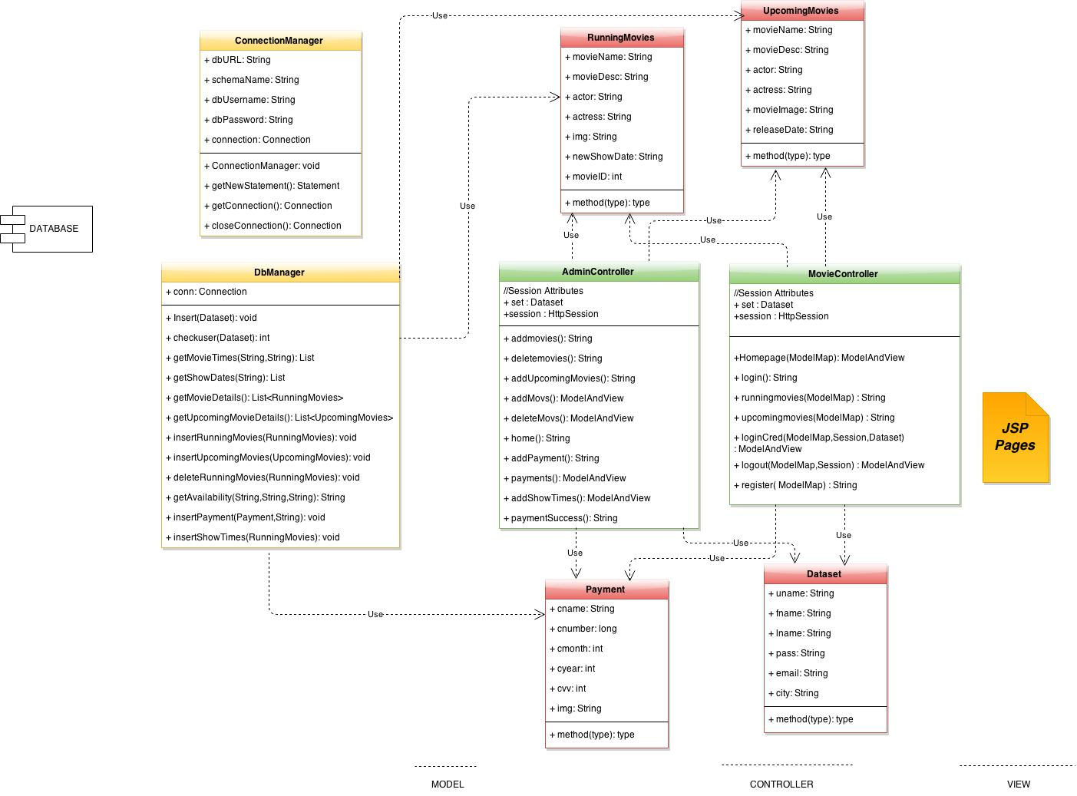

1. **Database Schema Diagram :**

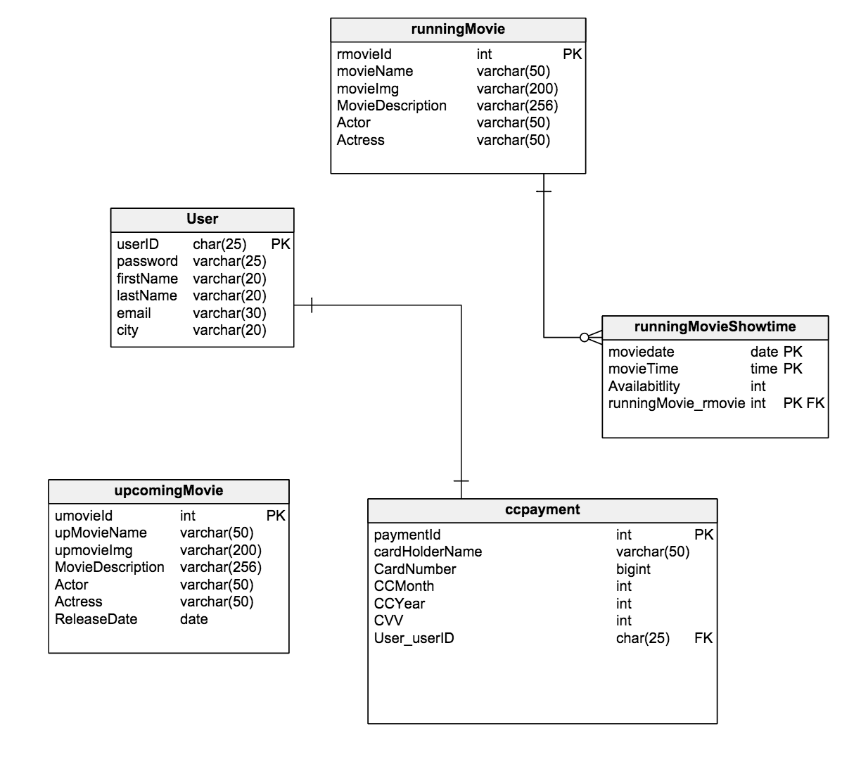

## Installation instructions

**Software to be configured:**

* Eclipse IDE
* Mysql
  + Give your MYSQL password in the parameter of ConnectionManager.java file in “com.movies.db” package
* Apache Tomcat 8 for Eclipse
* Run the database script ‘ssdi.sql’ attached along with the source code for the database creation.
* Use one of already created users to login or create one on the website. For admin , username =admin , password =admin .

**Steps to be followed after Installation of software’s:**

1. Import the Source Code in Eclipse.
2. Configure the Apache Tomcat Server in Eclipse.
3. Add Jars listed Below:

* Spring 4.1.6
* Junit 4.12
* Ajax4jsf 1.1.0
* Com.mysql.jdbc_5.1.5
* Jstl 1.2
* Selenium-2.45.0-srcs
* Selenium-2.45.0
* Hamcrest-core-1.3

1. Compile and Run the Project.

Path to be used while running the project would be

<http://localhost:8000/SpringMVC/Homepage>